FARCURA NEWSLETTER No. 4

Project update
Welcome to the 4th and final newsletter of our Erasmus + project Farcura (Fostering Inclusion through Social Farming). Over the last two years our project partnership, comprised of educational and third sector organisations from Slovenia, Belgium, Germany, Portugal and Ireland has been working together to create greater, more widespread awareness of social farming. Sharing experiences of social farming from each of our partner countries has helped us to further appreciate the richness and diversity of social farming activities throughout Europe. We have seen how effective it is at addressing the needs of vulnerable groups and how good it is at reaching out to isolated people and connecting them with their community. We are so grateful to all of the participants, farmers and stakeholders who helped us to develop the elements of this project.
Here are the highlights of our collaboration

Training Course
The Farcura training course is a six module introduction to social farming. Users will get a comprehensive overview of social farming. The course looks at practical examples of social farming such as building relationships with participants and with service organisations; it provides tips on communication and conflict management; looks at the day to day organisation of activities on the farm and gives tips on the enterprise planning and business management of a social farm.
The course is available in French, German, Slovenian, Portuguese and English.
Access the training platform here

Case Studies
Farcura presents 14 case studies of innovative social farming enterprises. The case studies demonstrate how social farms helps people with lots of different challenges and gives comfort to farmers and participants alike. There are case studies from Germany, Slovenia, Portugal and Ireland. They are available in French, German, Slovenian, Portuguese and English and you can read them here

Social Farming Report
We examined the evolution and current status of social farming in each of our partner countries and in the EU as a whole and summarised our findings in a report. The report presents the similarities and contrasts of farming and social farming activities in the partner countries; gives an overview of the different types of participants and service organisations; highlights policy instruments and identifies the challenges and opportunities faced by the sector.
Read the Summary Report here

Conferences
Throughout September and October 2021 each of the partner countries held a conference to present the training course and the other activities of the Farcura project. In some countries, because of restrictions on gatherings it was only possible to hold virtual events.
European conference - Belgium
The Belgium conference brought together key speakers from different spheres of social farming to present their experiences and research, and discuss the future of social farming activities in the EU.
The key speakers included Dermot Carroll (TUS), who introduced the project and presented a tour of the online training platform; Joe McCrohan, who along with Eamon Horgan presented on Kerry Social Farming in Ireland. They provided inspirational testimonies regarding the experiences of farmers and participants in Ireland’s only voluntary social farming initiative. Goran Miloševič showcased Korenika Eco-Farm in Slovenia and the benefits of multi-functional activities in creating a resilient social farm. Deirdre O’Connor (UCD) shared insights from the Green4Care project that can be applied to other social farming projects. Francesco Paolo Di Iacovo (UNIPI) discussed social farming as a smart solution that has an incredible potential to provide key services in a changing world. Finally, Elena Schubert (European Commission) discussed the European strategies and policies relating to social farming in Europe.
The conference concluded with an insightful panel discussion that touched upon the incredible impact of social farming on individuals, communities and societies at different scales and levels. The audience has responded with very positive feedback, and we hope this conference inspired individuals to engage in social farming, while providing them with essential tools to do so.

Irish conference
The Irish conference was held on the farm of Mike O’Sé. Attended by over 50 people it was an excellent opportunity for farmers, service providers, participants and public representatives to meet and chat with each other. Guests were treated to a tour of Mike’s farm and enjoyed a hearty lunch. The presentations highlighted the many positive aspects of social farming while also pointing to the challenges it faces. Speakers on the day were Mike O’Sé (Social Farmer), Michael Cahill (SKDP), Noel Spillane (Kerry Social Farming), Liz Kennedy (TUS), Dermot Carroll (Farcura), Gerald O Sullivan and the Kerry Parents and Friends Association (social farm participants), Brian Smith (Social Farming Ireland), Nicky Green (Field of Dreams), Sheila Kelleher (IRD Duhallow), Aoibeann Walsh (Social Farming in Northern Ireland) and Brendan O Keeffe.
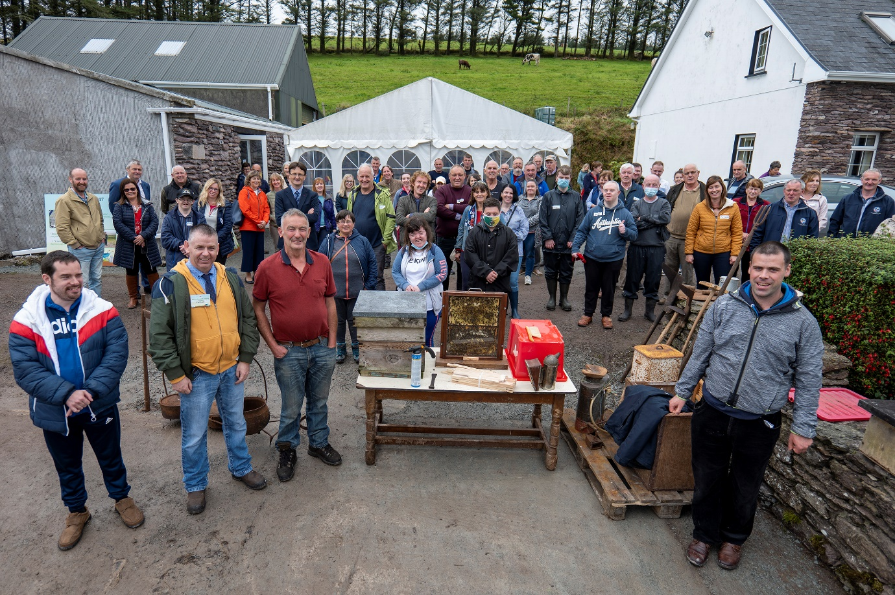
Social Farming Event Ireland

German Conference
In Germany, the Multiplier Event was only possible in virtual form due to the current pandemic situation. On the one hand, this was a pity, but on the other hand, it gave the two German project partners, the University for Sustainable Development Eberswalde (HNEE) from Brandenburg and Hof und Leben GmbH (HuL) from Bavaria, the opportunity to jointly host the event and invite participants from all over Germany.
The event itself took place on 29 September. Participants included representatives from ministries, associations, development agencies, advisory agencies for social farming and interested people with an agricultural or social professional background. HNEE and HuL used the opportunity to explain the Farcura project, its approach to the topic and the results of the situation analysis and case studies. They were supported in this by Urte Meves. Her farm in the federal state of Schleswig-Holstein was one of the social farming providers studied in the project (http://www.meves-hof.de/). Urte Meves presented her farm and impressively described her experiences, current challenges and ideas for the further development of her social farm.
Of course, the event also included a presentation of Farcura's online learning platform and a practical introduction to its use. Some participants took advantage of this to register directly during the event.
The organisers were particularly pleased that the participants also took the opportunity to actively participate in this virtual format, to ask questions and to exchange experiences.
Portuguese Conference
In Portugal, the Multiplier Event took place on 8th of October. It was an online meeting due to the pandemic situation. Participants included people representing social services (public and non-public institutions), such as the Local Council (Câmara Municipal de Arouca), associations, and people interested in social farming and with some agricultural knowledge/experience.
In the beginning of the event, there was an opportunity to briefly present the FARCURA project. The organisers emphasized the key objectives of the FARCURA project and also presented the video that’s available on FARCURA site, which also includes all of the projects’ partners. Furthermore, in this event, the organisers explained the social farming concept, including a brief of major opportunities and challenges associated with this approach applied to the Portuguese context. After that, an association that develops its intervention through social farming (Associação A4 - https://associacaoa4arc.wixsite.com/website) presented its experience of social farming - it was also one of the social farming providers studied in the FARCURA project.
After that, the organisers presented Farcura’s learning platform and explained briefly the course’s structure, including some information about the modules and also how the participants could register themselves.
At the end of the event, there was an opportunity to ask some participants questions and exchange experiences and ideas.
The organisers received very positive feedback.

FarmElder Project – social farming for the elderly
Our partnership is delighted to announce that we have received funding from the Erasmus Plus Programme of the European Union to continue our work in social farming. In our latest project we will be examining the potential for developing social farming projects that address some of the challenges faced by elderly people.
The Farmelder project will look at the needs of elderly people in the partner countries and produce a training course and case studies on how social farms can benefit elderly people. We will also create a series of inspiring videos that demonstrate the wonderful experience that social farming gives its participants.
We will be commencing the project in January 2022 and we look forward to working with all of our stakeholders and partners once more.

